Miguel Fernandez Brazon
2/8/2026
Module 4.3 Assignment
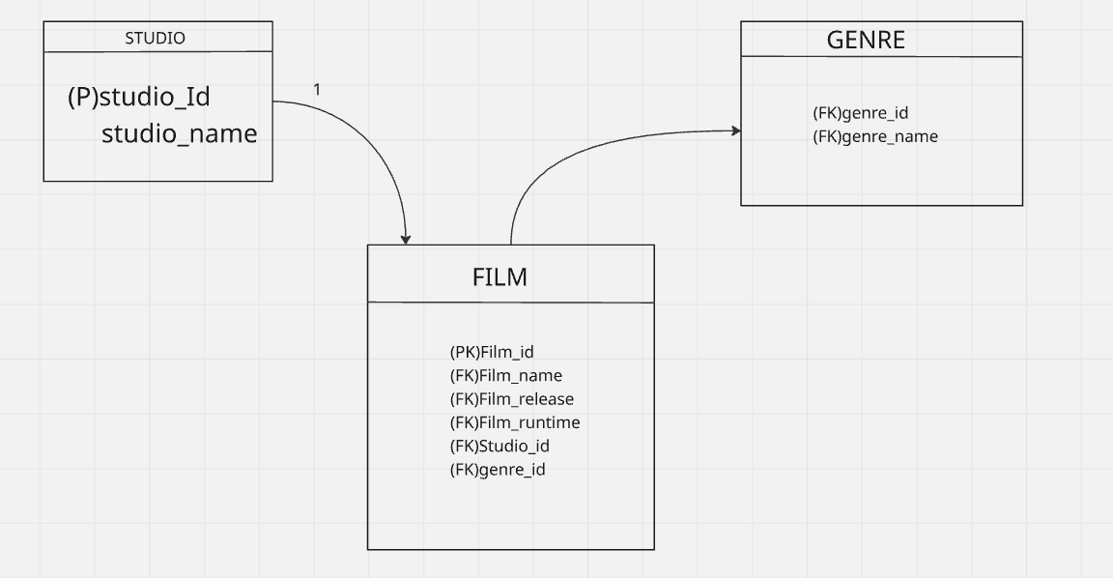
https://github.com/concord808030-tech/CSD310-300O-

